

POWER BI PORTFOLIO PROJECT REPORT

BY SAAD SALMAN DA2



January 25, 2025

**Power BI Portfolio project Report : FlyingWhale customer’s flight activity and loyalty insights**

1. **Introduction**

This Report provide valuable insights, pattern and trends for FlyingWhale Airline. This Report uncovers insights ,trends and patterns by analyzing Customers Flight Activity and customer Loyalty history Data , as well as cancellations data. This will improve travel experience , customer’s retentions and new enrollments. This report summarizes key findings and provide recommendations from the analysis conducted.

1. **Dataset overview**

The analysis is done using the following datasets:

**Flying activity Dataset :**

1. **Loyalty Number:** A unique identifier for each customer's loyalty account.
2. **Year and Month:** Period details for analysis.
3. **Flights Booked:** Number of flights booked by the member during the period.
4. **Flights with Companions:** Number of flights booked with additional passengers.
5. **Total Flights:** Combined total of Flights Booked and Flights with Companions.
6. **Distance:** Flight distance traveled in kilometers during the period.
7. **Points Accumulated:** Loyalty points earned in the period.
8. **Points Redeemed:** Loyalty points redeemed during the period.
9. **Dollar Cost Points Redeemed:** Dollar equivalent for points redeemed in Canadian Dollars (CDN).

**Customer Loyalty history Dataset:**

1. **Loyalty Number**: A unique identifier for each customer's loyalty account.
2. **Demographics:** Country, Province, City, Postal Code, Gender, Education, Salary, Marital Status.
3. **Loyalty Card:** Current loyalty card status
4. **Customer Lifetime Value (CLV):** Total invoice value for all flights ever booked by the member.
5. **Enrollment Details:** Enrollment Type (Standard / 2018 Promotion), Enrollment Year, Enrollment Month.
6. **Cancellation Details: C**ancellation Year and Month if applicable.

I have created another table named as Customer Loyalty Cancellations from customer loyalty history table, this new table contains only cancellations info.

1. **Analysis and findings**

**3.1 Flying activity analysis**

**Monthly and yearly flight booking pattern**

The chart below shows the booking pattern over the months of two years, 2017 and 2018. In 2017, bookings grew incrementally from January, peaking at around 80,000 in July before gradually lessen towards the end of the year, hitting its lowest in December at about 50,000. For 2018, the bookings were the lowest in January at about 50,000, increased to reach its peak in July at about 100,000 and then went down again towards the year-end but improved a bit during December.  
The data clearly suggests a seasonal trend, with maximum flight bookings made mid-year: June/July in both years probably coinciding with summer vacation requirements. The trends are downward, towards the end of the year; this could relate to lesser travelling activity during the winter period. In 2018 the booking activity is more as compare to 2017.

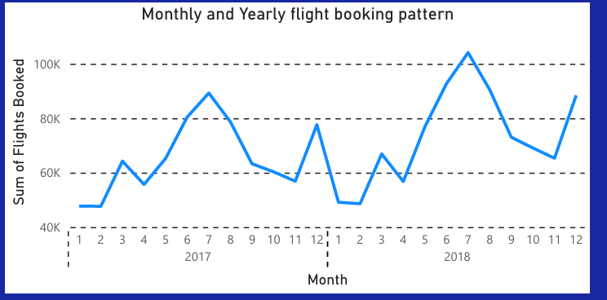

**Correlation between flight distances and loyalty points accumulated.**

The chart below shows that flight distances and loyalty points are directly proportioned as one increases the other also increases. This can be due to some reward or incentive where points are redeemed at fixed distance per unit travel. This correlation can be used to analyze customer behavior and optimize reward mechanisms for better engagement.

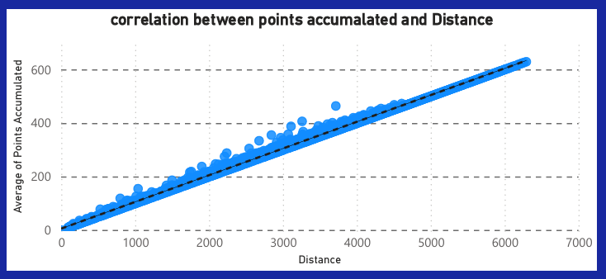

**Impact of companion bookings on loyalty points redeemed**

the Chart below shows that 3 flights with companion has the highest sum of points redeemed. Which then decreases as the number of flights increases. This tells us that most loyalty points redeemed when the moderate number of flights with companions, suggesting a specific pattern of group or family travel behavior.

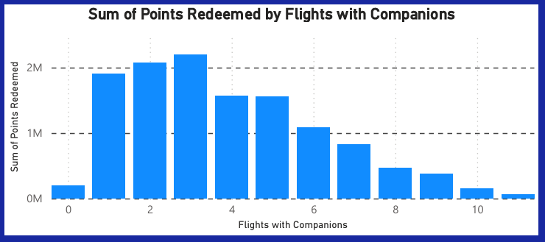

**3.2 Loyalty segmentation**

**Customers segmentation based on loyalty card status.**

Chart below shows that the card ‘Star’ has most sum of flights as compare to other cards. Furthermore the chart also suggest that in each card july is the month in which sum of flights is the highest . suggesting a seasonal pattern. January and febraury are the having lowest total flights across each card. Aurora has the lowest total flights.

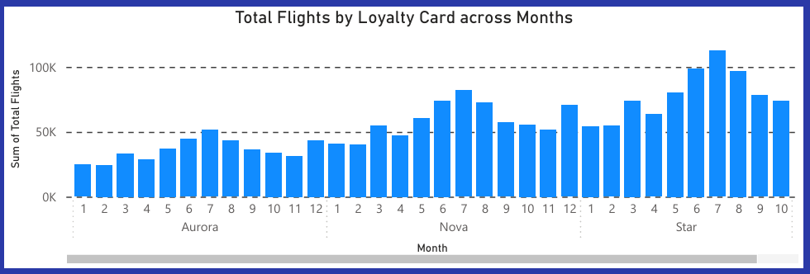

**Number of loyalty customers by Marital Status**

Chart Below shows that mostly loyalty customers are married followed by singles. The number of married customers is 9.7k , for singles it is 4.5k and for divorced it is 2.5k.

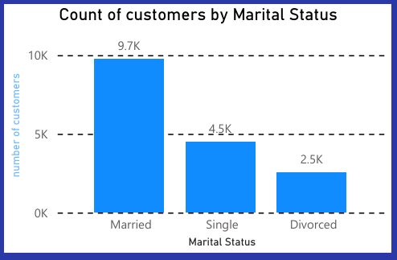

**Flights booked by loyalty card and broken up by gender**

The chart below shows that :

The sum of flights booked by both gender using Aurora loyalty card is same.

The sum of flights booked by female using Nova loyalty card is slightly more then males using Nova.

The sum of flights booked by male using Star loyalty card is slightly more then Females using Star.

Overall star loyalty card has the highest number of flights booked while Aurora Loyalty card has the lowest number of flights booked.

See below chart

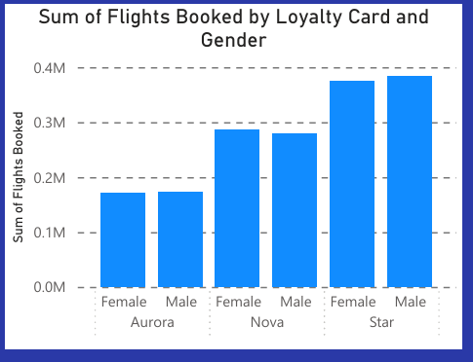

**Median distance by Loyalty card tier**

Chart below shows that loyalty card tiers ‘Star’ and ‘Aurora’ has the highest median distance with slight difference. Nova has the lowest median distance.

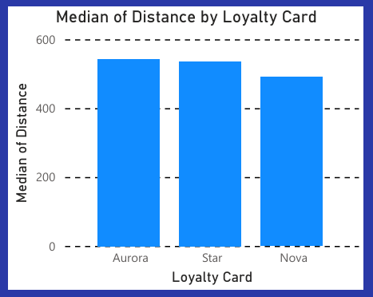

**Trends in Customer Lifetime Value (CLV) across loyalty segments.**

Aurora has the highest CLV , Followed by Nova and at the last Star has the lowest CLV.

See below

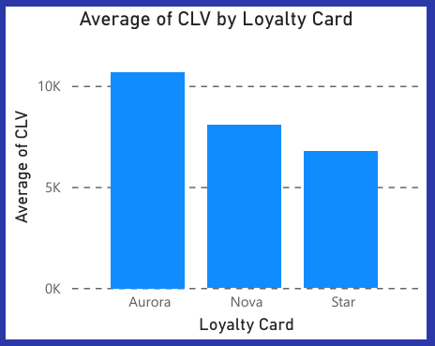

**3.3 Enrollment and Cancellation Trends**

**Average duration of enrollment among cancelled members by province:**

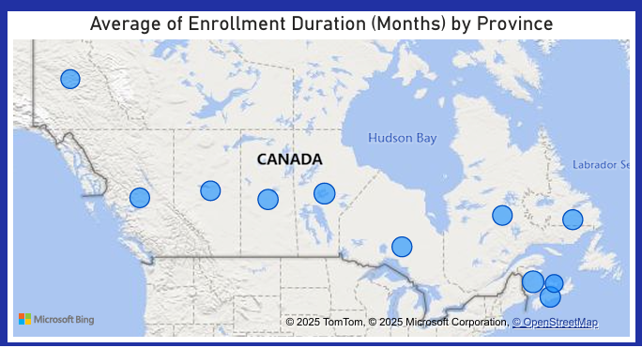

**Most popular months for cancellations**

Most popular months of cancellations are August, November ,December

See chart Below

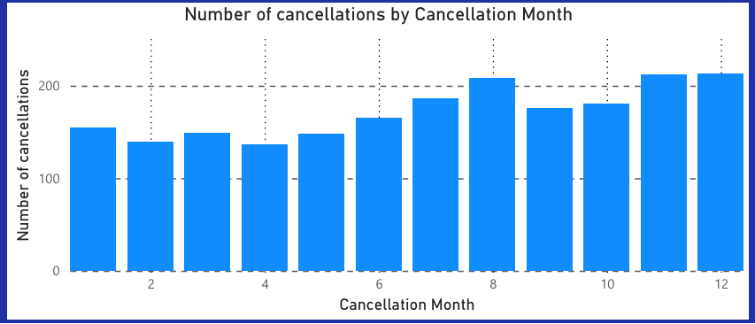

**Cancellations by education**

The pie chart below illustrates the percentage share of cancellations by education level. The largest share, 62.22%, is held by individuals with a Bachelor's degree, followed by 25% from those with a College education. The other categories, namely Doctor, High School, and Master, make up smaller portions at 4.64%, 3.14%, and 0.07%, respectively.

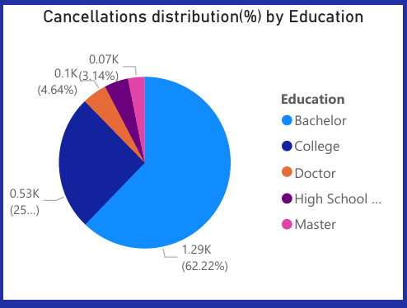

**Cancellations by Marital status**

This pie chart shows the percentage distribution of cancellations according to marital status. The majority, 58.73% (1.21K), is married. The second major group is the singles, 27.11% (0.56K). The smallest share is attributed to the divorced, 14.08% (0.29K). This data is a clear manifestation of a big gap in cancellation trends among the different marital statuses.

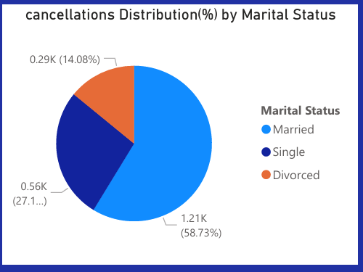

**Enrollment duration for each Loyalty card**

The chart below shows the sum of enrollment months for three categories of loyalty cards: Star, Nova, and Aurora. Out of these three, the sum of enrollment months for the Star loyalty card is the highest; for Nova, it is second; and for Aurora, the lowest. Therefore, customers with a Star card enroll for longer durations than the others.  
  
  
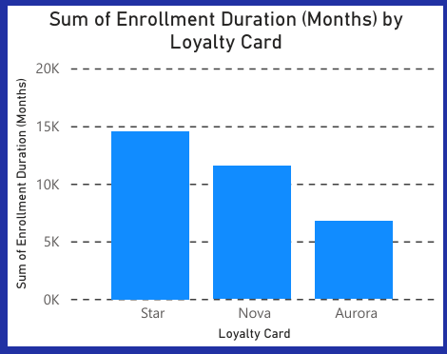

1. **Recommendations**

Following are the actionable recommendations:

1. Offer special discounts or promotions for off-peak months, such as January, February, and December, to improve flight sales during these periods of the year while maintaining a relatively stable revenue.
2. Increase promotions for peak months: June and July
3. Adjust Loyalty point redemption rate to stimulate long-distance travels and frequent customers.
4. Give rewards for bookings of companions and especially for group or family members.
5. Reward star cardholders as an exclusive reward, like bonus loyalty points or renewals at discounted rates.
6. Engage strategies with Aurora card-holders to increase participation and loyalty.
7. Concentrate campaigns towards married and single customers, because they are the majority of the customer base.
8. Customers' gender-specific usage trend should be used in designing their targeted advertisements and offers.
9. Introduce milestone rewards for customers in Aurora and Nova segments that will earn huge CLV, and reward further engagements.
10. Reward loyalty milestones, like anniversary bonuses or recognition for Customers with extended enrollment durations.
11. Investigate high cancellation periods, that is August, November, and December; have retention strategies like flexible rescheduling, incentives for continued enrollment, or proactive customer support.
12. Retain Bachelor's and College graduates with programs like personalized communication or rewards for loyalty.
13. Study the provinces that have shorter enrollment period as a targeted means for localized campaigns.
14. Create renewal discounts for Star and Nova cardholders so they stay in for extended periods.
15. Localized knowledge should be used to tailor promotions such as travel packages for improvement in customer satisfaction and retention.
16. **Conclusion**

This report provide a detailed analysis of FlyWhale airline flight activities, cancellation , and loyalty segmentations data, providing valuable insights for the improvement of business of this airline. The findings highlights valuable insights into customers demographics, seasonal trends, and customers behaviors. As well as cancellations patterns/trends were also uncovered to help create future strategies. Based on the analysis some actionable recommendations were also given for betterment of the FlyWhale.